Instructions for Poster Formatting:
The posters will be uploaded to Gathertown for the poster session. This will require two images for each poster. The main document is the poster in the traditional sense, but we also need a thumbnail image that will be displayed in the plan view of the virtual venue. Please forward both files via email to the address below.

Format Restrictions

Main document:
- .png, .jpg or .webp format are the only file types that may be used
- At least 1000px (26.46cm) wide
- At least 600px (15.88cm) high
- Min. resolution: 72 ppi
- Maximum file size is 3MB.
- No transparent background. All transparent backgrounds will be converted to black.

Preview “thumbnail” document:
- .png .jpg or .webp format
- A copy of the main poster document that has been made smaller.
- Recommended width is half of the main document.
- Recommended height is half of the main document.

Resizing your poster to fit the dimension requirements
The most simple way to edit the dimensions of a poster is using a slideshow editor such as powerpoint or keynote. Here we’ll show you step by step details on how to change your dimensions.

Powerpoint instructions
- Select the Design tab of the toolbar ribbon.
- Select Slide Size icon near the far right end of the toolbar.
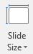
- Select Custom Slide Size.
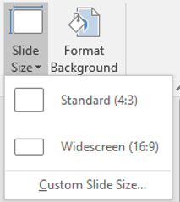
- Change the Width and Height to be larger than the minimum size guidelines above (26.46cm and 15.88cm) and click okay.
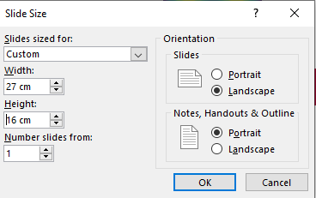
- Click Ensure Fit to make sure the resizing doesn’t stretch your poster in an undesirable way.
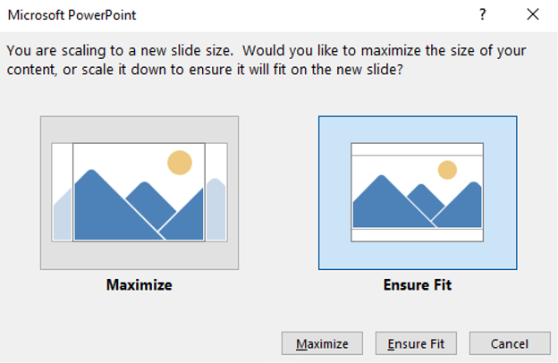
- Repeat to create the preview poster with half of the width and height.

Send to Zsuzsa Helyes by 21 December 2021.
IMPORTANT: please do not change the title of this email.
We appreciate that this is an early deadline, we will do our best to deal with late submission but cannot guarantee they are uploaded before the conference.

