Sample Abstract of ISSE 2024: Information for Authors

Presenting Author, Second Author, Third Author, …
Affililiation(s), City(s), Country(ies)

Abstracts are limited in length to one page. Any extra pages will be deleted when creating the Book of Abstracts of the event. The total width of the abstract must not exceed 16.5 cm (6.5 inches); the height is limited to 23.5 cm (9.2 inches). For A4 paper, the abstract should have 22.5 mm margins on each side and 31 mm margins top and bottom. The complete printed area including title, authors, text, figures and references must fit within these margins. For Word manuscripts, an editable template will be available for download at the conference website. For other manuscripts, the font to be used is Times New Roman 12pt.
The TITLE (in BOLD CAPITAL LETTERS) is centered at the top of the page. It is followed by the authors’ names in bold type. Their affiliation and complete address is in italic type – all centered. Use single spacing throughout the document, but insert a blank line between the title and the authors as well as between the authors’ affiliations and the text. No page numbering should appear.
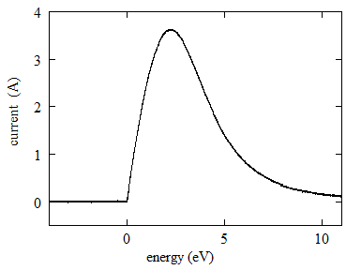
Figure 1: Example of a figure.
No blank line is required in-between succeeding paragraph. References should appear in square brackets [1]. Figures must be inserted at the proper position and size in the text, and should be superscribed readable. All figures should be cited in the text by number (Figure 1, Figure 2). The use of figure captions is encouraged. They should be sufficient to explain the figures without the need to reference the text. Figure captions should be typed using the font Times New Roman 10pt font.
Do not use multiple columns. However, the text may wrap around figures and captions.
At the bottom of the page, following a horizontal line as separator, the name and the e-mail address of the presenting author should be given. The text should be centered. This information will be published in the Book of Abstract, which will be available online and handed out to all participants.
The conference language is English.
In order to avoid printing problems caused by the text format we encourage to submit your abstracts in PDF and Word format. Please recheck margins before submission.

References
[1] A.B. Sample et al, Phys. Rev. Lett. xx (19xx) xxxx.

_____________________________________________________________________________
Submitting Author: jane.smith@office.com

Request of presentation type: *oral or poster

*You can choose either oral or poster.

